My Plant Corner
Plant Care Tracker Project Report

Project Title
My Plant Corner — A JSON-Based Plant Information Display Website

Project Explanation
My Plant Corner is a small website for viewing a list of houseplants and their care information. It reads the sample records from data.json. The page can search by plant name, type, or room; filter plants by watering status; sort the list; and open extra care notes. The records stay read-only.
I made this project to practise reading structured data and showing useful information on a web page. Each JSON record includes the plant name, type, room, last-watered date, watering interval, light preference, and a short care tip. The watering status is calculated from the date and interval.

Screenshots of the Main Module
The main screen shows the collection totals, search and filter controls, and plant cards after data.json is opened.
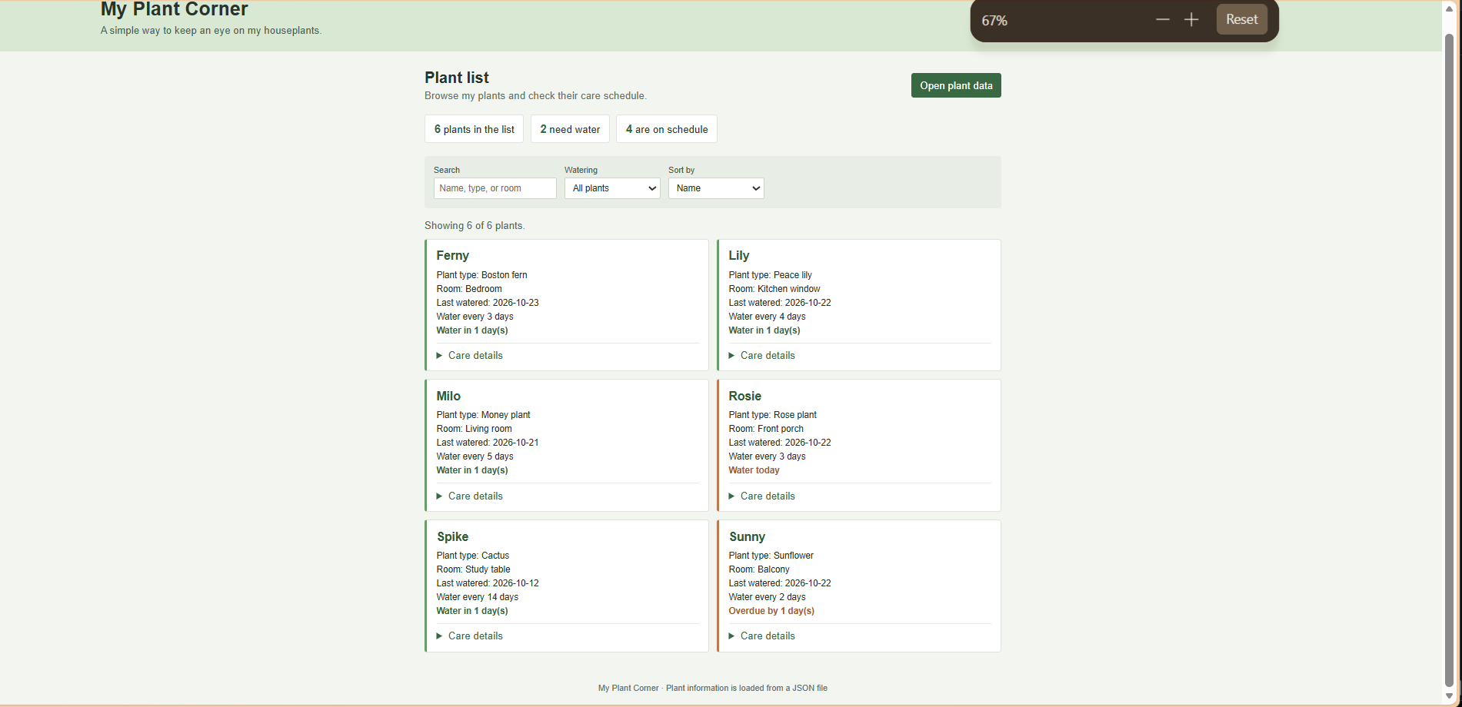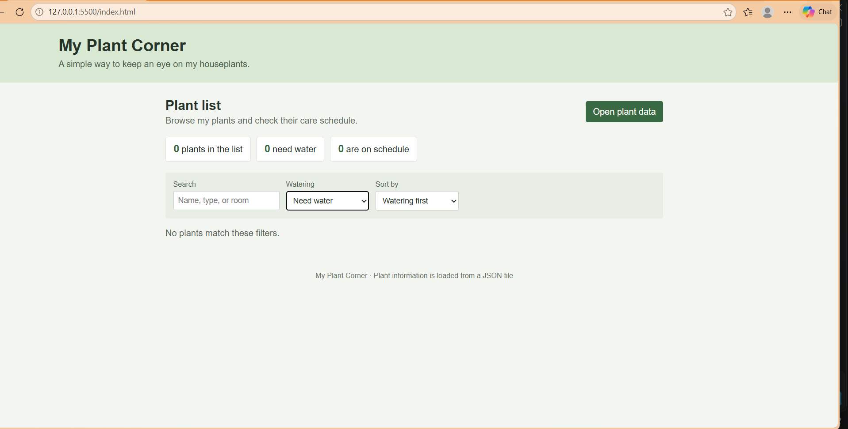

Main Module Logic Code

When a JSON file is selected, FileReader reads it and JSON.parse turns the text into an array. The script checks that the required fields are present, calculates how many days remain before watering, then applies the search, filter, and sort choices. It builds each card with regular DOM elements and textContent. Care details expand when their summary is clicked. Invalid data produces a short message instead of cards.
var fileInput = document.getElementById('json-file');
var plantList = document.getElementById('plant-list');
var message = document.getElementById('message');
var searchBox = document.getElementById('search');
var waterFilter = document.getElementById('water-filter');
var sortOrder = document.getElementById('sort-order');
var plants = [];

function daysUntilWater(plant) {
var dateParts = plant.lastWatered.split('-');
var lastWatered = new Date(dateParts[0], dateParts[1] - 1, dateParts[2]);
var currentDate = new Date();
var today = new Date(currentDate.getFullYear(), currentDate.getMonth(), currentDate.getDate());
var daysSinceWatering = Math.floor((today - lastWatered) / (1000 * 60 * 60 * 24));
return Number(plant.waterEveryDays) - daysSinceWatering;
}

function makePlantCard(plant) {
var card = document.createElement('article');
var daysLeft = daysUntilWater(plant);
var status = document.createElement('p');
var details = document.createElement('details');
var summary = document.createElement('summary');
var light = document.createElement('p');
var tip = document.createElement('p');

card.className = 'plant-card';
if (daysLeft <= 0) {
card.classList.add('needs-water');
if (daysLeft === 0) {
status.textContent = 'Water today';
} else {
status.textContent = 'Overdue by ' + Math.abs(daysLeft) + ' day(s)';
}
} else {
card.classList.add('on-schedule');
status.textContent = 'Water in ' + daysLeft + ' day(s)';
}
status.className = 'water-status';

var name = document.createElement('h3');
name.textContent = plant.name;
card.appendChild(name);

var type = document.createElement('p');
type.textContent = 'Plant type: ' + plant.type;
card.appendChild(type);

var room = document.createElement('p');
room.textContent = 'Room: ' + plant.room;
card.appendChild(room);

var lastWatered = document.createElement('p');
lastWatered.textContent = 'Last watered: ' + plant.lastWatered;
card.appendChild(lastWatered);

var schedule = document.createElement('p');
schedule.textContent = 'Water every ' + plant.waterEveryDays + ' days';
card.appendChild(schedule);
card.appendChild(status);

summary.textContent = 'Care details';
light.textContent = 'Light: ' + plant.sunlight;
tip.textContent = plant.careTip;
details.appendChild(summary);
details.appendChild(light);
details.appendChild(tip);
card.appendChild(details);

return card;
}

function showPlants() {
var searchText = searchBox.value.toLowerCase();
var filterValue = waterFilter.value;
var shownPlants = plants.filter(function (plant) {
var matchesSearch = plant.name.toLowerCase().indexOf(searchText) !== -1 ||
plant.type.toLowerCase().indexOf(searchText) !== -1 ||
plant.room.toLowerCase().indexOf(searchText) !== -1;
var needsWater = daysUntilWater(plant) <= 0;
var matchesWater = filterValue === 'all' ||
(filterValue === 'due' && needsWater) ||
(filterValue === 'ok' && !needsWater);
return matchesSearch && matchesWater;
});

if (sortOrder.value === 'name') {
shownPlants.sort(function (a, b) { return a.name.localeCompare(b.name); });
} else if (sortOrder.value === 'room') {
shownPlants.sort(function (a, b) { return a.room.localeCompare(b.room); });
} else {
shownPlants.sort(function (a, b) { return daysUntilWater(a) - daysUntilWater(b); });
}

var dueCount = plants.filter(function (plant) {
return daysUntilWater(plant) <= 0;
}).length;
document.getElementById('total-count').textContent = plants.length;
document.getElementById('due-count').textContent = dueCount;
document.getElementById('ok-count').textContent = plants.length - dueCount;
plantList.innerHTML = '';

for (var i = 0; i < shownPlants.length; i++) {
plantList.appendChild(makePlantCard(shownPlants[i]));
}

if (shownPlants.length === 0) {
message.textContent = 'No plants match these filters.';
} else {
message.textContent = 'Showing ' + shownPlants.length + ' of ' + plants.length + ' plants.';
}
}

fileInput.addEventListener('change', function () {
var file = fileInput.files[0];
if (!file) return;

var reader = new FileReader();
reader.onload = function () {
try {
var plantData = JSON.parse(reader.result);
var validList = Array.isArray(plantData) && plantData.every(function (plant) {
return plant.name && plant.type && plant.room && plant.lastWatered &&
Number(plant.waterEveryDays) > 0 && plant.sunlight && plant.careTip;
});
if (!validList) throw new Error('The plant data is incomplete.');

plants = plantData;
showPlants();
} catch (error) {
plants = [];
plantList.innerHTML = '';
message.textContent = 'Please choose a valid plant JSON file.';
}
};
reader.readAsText(file);
});

searchBox.addEventListener('input', showPlants);
waterFilter.addEventListener('change', showPlants);
sortOrder.addEventListener('change', showPlants);

Conclusion
My Plant Corner now gives a useful read-only view of plant records from JSON. Search, watering filters, sorting, and expandable care notes make the list easier to use while keeping the code and data simple.

Learning Outcomes
- Built a web page with HTML and applied a responsive layout with CSS.
- Read a local JSON file in the browser with a file input and FileReader.
- Converted JSON text into JavaScript data with JSON.parse.
- Created plant cards with a loop and DOM methods, then added search, filters, sorting, and expandable details.
- Checked the loaded records and showed a message when the file was not valid plant data.

GitHub Repository Link
- https://github.com/prathamsuthar10-sab/Web-project-wt

